Antipsychotic Monitoring
Patient Information Leaflet

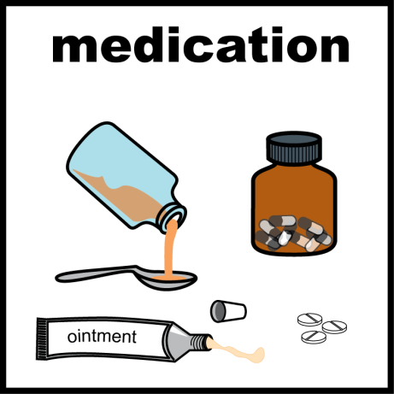
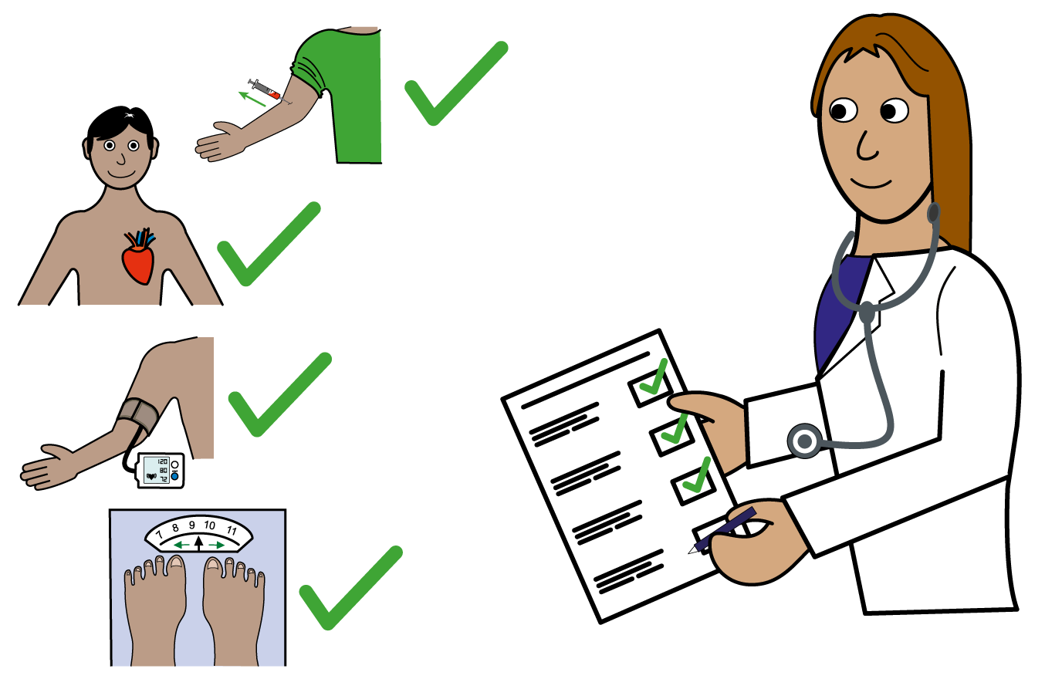
Antipsychotic medication is used to treat a range of mental health conditions.
My Antipsychotic is ………………………………..……………

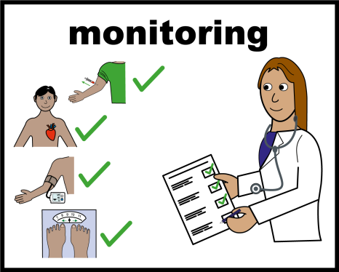
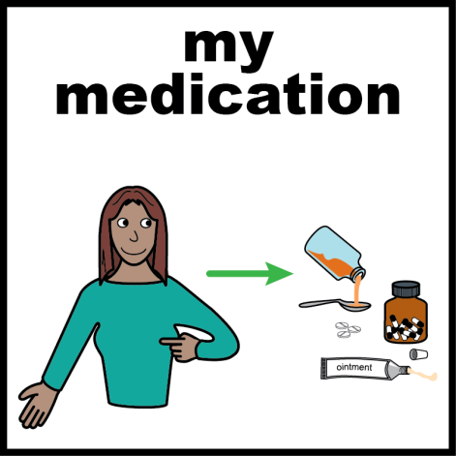 | Antipsychotic monitoring is when your doctor checks that your medication is keeping you well.  This leaflet will explain why this is important.  You should have this monitoring  - Before you start taking the antipsychotic medication.  - 3 Months after you start taking the medication.  - 12 Months after you start the medication.  And then every year.  Your doctor will tell you what monitoring you need. Your monitoring will be done by your GP or the hospital.

What do we check?

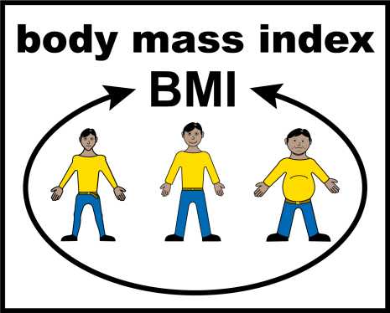
Weight, Body mass index (BMI) and waist measurement
It is important that you are active and eat a healthy diet, as weight gain can cause problems for your health.

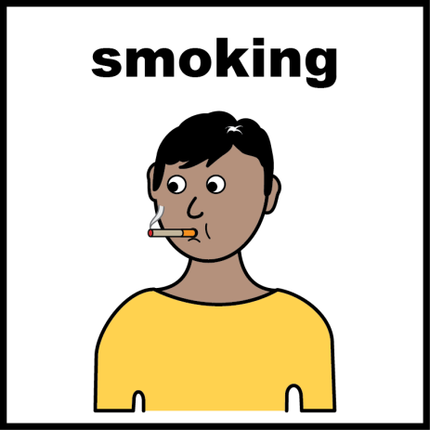
Smoking
If you smoke, stopping is the most important thing you can do for your health.
Smoking can change how some antipsychotics work. It is important to let your doctor know if you smoke or plan to stop smoking.

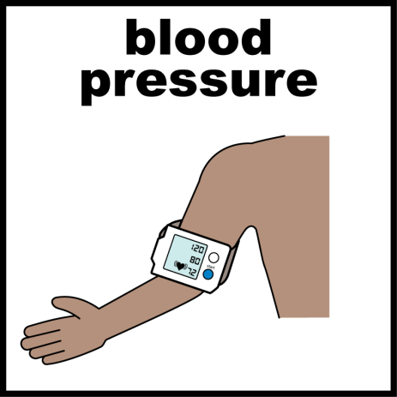
Blood pressure and pulse
To check that your blood pressure is normal.

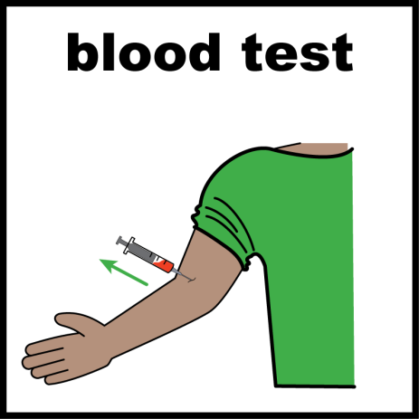
Blood tests that we check:
- Sugar levels in your blood.
This is called HbA1c
- Liver, kidney and full blood count –
This monitors your health.

- Cholesterol – This is fat in your blood. We check that this is normal.

- Prolactin - This is a hormone that can cause side effects if it gets too high. (This is not always needed)
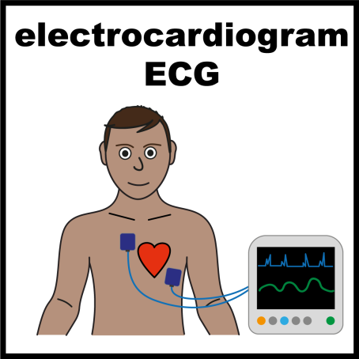
Heart health – Electrocardiogram (ECG)
chest which is connected to a machine that checks your heart. This is not always needed.
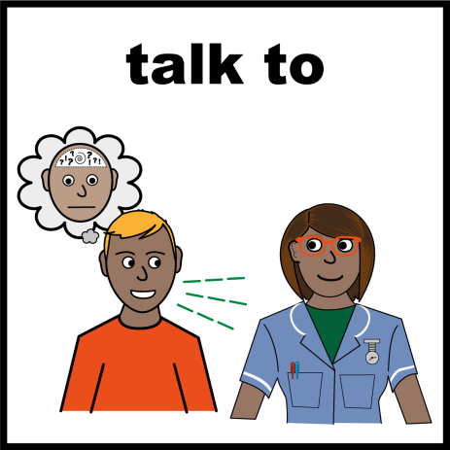
Mental health check
This is to make sure that your antipsychotic medication is still working to keep you well.

Some medicines can cause side effects like making you feel sleepy.
If you think you have any side effects talk to your doctor.

You should get a reminder when your antipsychotic monitoring is due.
It would be useful to record this in your calendar or your phone.

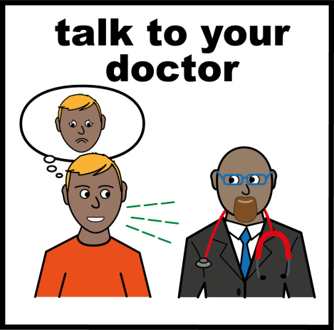
It is important to go for your antipsychotic monitoring every year.
If you have any questions speak to your GP or mental health specialist.
Do not stop taking your medication without speaking to your doctor first.

Services in Leeds to help you
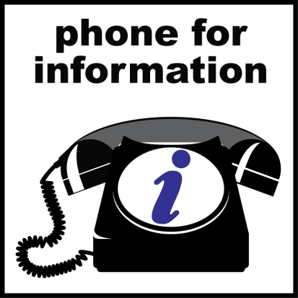
Mental Health Medicines Information Helpline: Speak to a pharmacist if you have questions about your mental health medication.
Phone- 0113 8555534
Open Monday—Friday 9-5pm.

Choice and Medication: Easy to access online information about mental health medication. www.choiceandmedication.org/leedsandyorkpft
Mindwell: Mental health information for everyone in Leeds. www.mindwell-leeds.org.uk

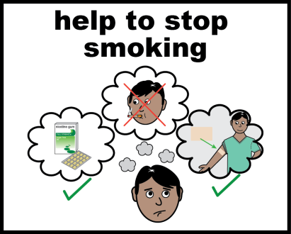
Help to stop smoking: Remember to tell your GP or mental health specialist if you plan to quit smoking.
https://oneyouleeds.co.uk/be-smoke-free/

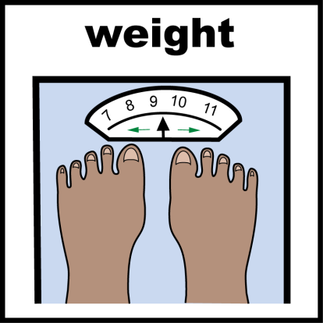
Help with your weight: One You Leeds can help you to manage your weight, eat healthy and be more active.
https://oneyouleeds.co.uk/manage-your-weight/

